Case Study: Real Time Fraud Detection in Financial Services

Submitted in partial fulfilment of the requirements of the degree of

## Bachelor of Engineering by

|  |  |
| --- | --- |
| **Name** | **Roll No** |
| Arshad Ahmed | 211202 |
| Ansari Furqan Mohd. Shaheen | 211205 |
| Ansari Usman | 211209 |
| Zuhaib Mazhar Kazi | 211221 |

Project Guide:

## Prof. Ahlam Ansari



**(Computer Engineering)**

## M.H. Saboo Siddik College of Engineering University of Mumbai

**2024-25**

## M. H. SABOO SIDDIK COLLEGE OF ENGINEERING

### 8, Saboo Siddik Road, Byculla, Mumbai - 400 008.

This is to certify that,

|  |  |
| --- | --- |
| **Name** | **Roll No** |
| Arshad Ahmed | 211202 |
| Ansari Furqan Mohd. Shaheen | 211205 |
| Ansari Usman | 211209 |
| Zuhaib Mazhar Kazi | 211221 |

Of Final Year (B.E. Semester VII) degree course in Computer Engineering, have completed the specified project report on,

Case Study: Real Time Fraud Detection in Financial Services

As partial fulfillment of the project work in a satisfactory manner as per the rules of the curriculum laid by the University of Mumbai, during the Academic Year July 2024 - Nov 2024.

Internal Guide External Examiner

## Project Report Approval for B. E.

This project report entitled **“Case Study: Real Time Fraud Detection in Financial Services”** by **Arshad Ahmed , Ansari Furqan Mohd. Shaheen , Ansari Usman , Zuahib Mazhar Kazi** is approved for the degree of Computer Engineering.

**EXAMINERS**

**1.**

**2.**

**SUPERVISORS**

1.

2.

**Date:**

**Place:** Mumbai

## Acknowledgment

We would like to express our gratitude and appreciation to our parents for motivating and encouraging us throughout our career.

We wish to express our sincere thanks to our Principal Dr. Ganesh Kame, M. H. Saboo Siddik College of Engineering for providing us with all the facilities, support, and wonderful environment to meet our project requirements.

We would also take the opportunity to express our humble gratitude to our Head of the Department of Computer Engineering Dr. Mohammed Ahmed Shaikh for supporting us in all aspects and for encouraging us with her valuable suggestions to make our project successful.

We are highly thankful to our internal project guide Prof. Ahlam Ansari whose valuable guidance helped us understand the project better, her constant guidance and willingness to share her vast knowledge made us understand this project and its manifestations in great depth and helped us to complete the project successfully.

We would also like to acknowledge with much appreciation the role of the Computer Department staff, especially the Laboratory staff, who permitted us to use the labs when needed and the necessary material to complete the project.

We would like to express our gratitude and appreciate the guidance given by other supervisors and project guides, their comments and tips helped us in improving our presentation skills.

Although there may be many who remain unacknowledged in this humble note of appreciation, there are none who remain unappreciated.

# Table of Content

|  |  |  |
| --- | --- | --- |
| **Sr. No.** | **Content** | **Page No.** |
|  | Abstract | 06 |
| 1. | Introduction | 07 |
| 2. | Problem Statement | 11 |
| 3. | Research Work | 12 |
| 4. | Comparative Analysis | 19 |
| 5. | Conclusion | 20 |
|  | References | 21 |

**List of Figures**

|  |  |  |
| --- | --- | --- |
| **Sr. No.** | **Figure Number** | **Page No.** |
| 1. | Figure 1 | 13 |
| 2. | Figure 2 | 16 |
| 3. | Figure 3 | 18 |

# Abstract

In the era of digital transactions, the proliferation of financial fraud poses significant challenges to the security and integrity of financial systems worldwide. Amidst this landscape, the role of big data has emerged as a critical tool for detecting and preventing financial fraud in digital transactions. This Review explores the multifaceted role of big data in combating financial fraud, highlighting its capabilities in identifying fraudulent patterns, enhancing risk assessment models, and enabling real-time fraud detection mechanisms. Big data analytics leverage vast volumes of structured and unstructured data from various sources, including transaction logs, user behavior patterns, and external threat intelligence feeds, to detect anomalies and suspicious activities indicative of financial fraud.

By employing advanced machine learning algorithms and predictive modeling techniques, big data analytics can analyze complex data patterns and identify deviations from normal behavior, enabling early detection of fraudulent transactions. Moreover, big data analytics play a crucial role in enhancing risk assessment models by incorporating a wide range of data points and variables, including transaction history, geographic location, device fingerprinting, and biometric data. These multidimensional risk assessment models enable financial institutions to assess the likelihood of fraud more accurately and efficiently, thereby reducing false positives and minimizing the impact on legitimate transactions. In addition to retrospective analysis, big data analytics enable real-time fraud detection mechanisms that monitor transactions in real- time and flag suspicious activities for further investigation. By leveraging streaming data processing and complex event processing technologies, financial institutions can detect and respond to fraudulent transactions in near real-time, mitigating potential losses and preventing further fraud.

# Introduction

Financial fraud in digital transactions poses significant challenges to the security and integrity of financial systems worldwide. In an increasingly interconnected and digitized economy, the threat of financial fraud has evolved, encompassing a wide range of illicit activities such as identity theft, payment fraud, and account takeover. As financial transactions migrate to digital platforms, fraudsters exploit vulnerabilities in the system to perpetrate sophisticated schemes, causing substantial financial losses and eroding trust among consumers and businesses alike .

The importance of detecting and preventing financial fraud cannot be overstated. Beyond the immediate financial losses incurred by individuals and organizations, financial fraud undermines confidence in the financial system, disrupts business operations, and threatens the stability of markets. Moreover, financial fraud can have far- reaching consequences, including damage to reputations, loss of customer trust, and regulatory scrutiny In this landscape, the role of big data has emerged as a critical tool for combating financial fraud in digital transactions. Big data refers to vast volumes of structured and unstructured data collected from various sources, including transaction logs, user behavior patterns, and external threat intelligence feeds. By leveraging advanced analytics and machine learning algorithms, big data enables financial institutions to analyze complex data patterns, detect anomalies, and identify suspicious activities indicative of fraud.

The use of big data in fraud detection offers several advantages over traditional approaches. Unlike manual methods, which rely on predefined rules and thresholds, big data analytics can analyze large volumes of data in real-time, enabling faster detection of fraudulent transactions. Moreover, big data analytics can incorporate a wide range of data points and variables, including transaction history, geographic location, device fingerprinting, and biometric data, to enhance risk assessment models and improve the accuracy of fraud detection .

In summary, the role of big data in detecting and preventing financial fraud in digital transactions is paramount in today's interconnected and digitized financial ecosystem. By harnessing the power of big data analytics, financial institutions can enhance their fraud detection capabilities, mitigate risks, and safeguard the integrity and trustworthiness of digital transactions. In the following sections, we will delve deeper into the mechanisms by which big data is utilized to combat financial fraud, explore real-world applications and case studies, and discuss future directions and recommendations for further research and innovation.

## Understanding Financial Frauds in Digital Transactions

Identity theft involves the unauthorized use of someone else's personal information to access financial accounts, obtain credit, or commit fraudulent transactions. Fraudsters often steal personal information such as social security numbers, credit card details, and passwords through phishing scams, data breaches, or malware attacks. Once acquired, this information is used to impersonate the victim and carry out fraudulent activities, such as opening new accounts, making unauthorized purchases, or applying for loans in the victim's name.

Payment fraud encompasses a variety of fraudulent activities involving the unauthorized use of payment instruments, such as credit cards, debit cards, and electronic funds transfers. Common types of payment fraud include card-not- present fraud, where fraudsters use stolen card details to make online purchases, and card skimming, where devices are used to capture card information at point-of-sale terminals or ATMs. Additionally, wire transfer fraud involves tricking individuals or businesses into transferring funds to fraudulent accounts through social engineering or phishing tactics.

Malware attacks involve the use of malicious software, such as viruses, trojans, or spyware, to infiltrate victims' devices and steal sensitive information or carry out unauthorized transactions. Malware can be distributed through various channels, including email attachments, infected websites, or removable media. Once installed on a victim's device, malware can capture keystrokes, record screen activity, or hijack browser sessions to steal login credentials or intercept financial transactions.

## Leveraging Big Data for prevention of Fraudulent Activities

To combat this evolving threat, organizations are increasingly turning to big data analytics—a powerful tool that harnesses vast volumes of structured and unstructured data to detect and prevent fraudulent activities. Big data analytics refers to the process of analyzing large and complex datasets to extract actionable insights and patterns. It encompasses a range of techniques, including data mining, machine learning, and predictive analytics, to uncover hidden patterns, correlations, and trends within the data.

Unsupervised learning algorithms identify patterns and clusters in data .Unsupervised learning algorithms can identify groups of transactions that exhibit similar characteristics, such as transactions originating from the same IP address, transactions occurring at unusual times, or transactions involving unusual amounts. By clustering transactions based on similarity, organizations can detect fraudulent activities that may not be apparent through traditional rule-based methods.

Some common sources of data used for fraud detection include: Transaction logs contain detailed records of financial transactions, including transaction amounts, timestamps, and transaction IDs. By analyzing transaction such as unusually large transactions, frequent transfers to unfamiliar accounts, or transactions occurring outside of normal business hours.. By analyzing user behavior patterns, organizations can detect suspicious activities, such as multiple failed login attempts, rapid changes in browsing behavior, or unusual purchasing patterns that deviate from the user's typical behavior. External threat intelligence feeds provide organizations with real-time information about known threats,

By detecting and responding to fraudulent activities in real-time, organizations can block suspicious transactions, freeze accounts associated with fraudulent activities, and notify stakeholders to take appropriate action. Additionally, real-time fraud detection mechanisms allow organizations to implement adaptive authentication measures, such as multi-factor authentication or behavioral biometrics, to verify the identity of users and prevent unauthorized access to accounts. By leveraging adaptive authentication measures, organizations can strengthen their defenses against fraud and protect their customers from unauthorized transactions.

## Authentication Protocols/Systems Implemented to Secure Financial Transactions

#### OpenID Connect (OIDC)

Description: Built on top of OAuth 2.0, OpenID Connect is an authentication layer that provides user identity information in a secure way.

Use Case: Used by financial institutions to authenticate users via third-party identity providers while maintaining high levels of security and privacy.

#### FIDO2 (Fast Identity Online)

Description: FIDO2 enables passwordless authentication using public key cryptography and biometric data. It uses two key components: the Web Authentication (WebAuthn) API and the Client to Authenticator Protocol (CTAP).

Use Case: Used for strong, multi-factor authentication in online banking apps, enabling users to authenticate with biometric data (fingerprint, facial recognition) or physical security keys.

#### Kerberos

Description: Kerberos is a network authentication protocol designed to provide secure authentication for client- server applications using secret-key cryptography.

Use Case: Commonly used in financial institutions' internal networks to authenticate users and systems across a network securely.

#### Multi-Factor Authentication (MFA) Protocols

OTP (Time-Based One-Time Password): Uses a shared secret key and the current time to generate one-time passwords that expire after a short period. Financial services use this protocol to ensure secure logins.

HOTP (HMAC-Based One-Time Password): Generates a one-time password based on a shared secret and a counter. It’s used in hardware tokens or mobile authenticator apps.

Use Case: Both TOTP and HOTP are frequently implemented in mobile banking apps and for online transaction authorizations to provide extra layers of security.

#### RADIUS (Remote Authentication Dial-In User Service)

Description: RADIUS is a protocol for centralized authentication, authorization, and accounting. It handles authentication requests from remote network access servers and authorizes users based on predefined policies.

Use Case: RADIUS is commonly used by financial institutions for remote access authentication, such as VPNs, network logins, and secure network infrastructure access.

#### Smart Card Authentication (PKI-Based Authentication

Description: Public Key Infrastructure (PKI)-based authentication protocols use a combination of public and private cryptographic keys for secure communication and identity verification.

Use Case: Smart cards with embedded chips are used in financial institutions to authenticate users for secure access to banking systems, online transactions, or ATM withdrawals.

#### SL/TLS (Secure Sockets Layer / Transport Layer Security)

Description: SSL and TLS are cryptographic protocols that provide secure communication over a network. TLS is the successor to SSL and is more commonly used today.

Use Case: Financial institutions use TLS to encrypt communications between users’ browsers and banking servers, ensuring data integrity and privacy during transactions.

#### 10.X.509 Certificates

Description:X.509 certificates are a standard for public key infrastructure (PKI) used in TLS/SSL protocols. They are used to authenticate users and devices by verifying their identity with a certificate authority (CA).

Use Case: Banks and financial institutions use X.509 certificates to enable secure, encrypted communication and verify identities during online banking sessions and financial transactions.

#### 12.WS-Federation

Description: WS-Federation is a protocol used to enable single sign-on (SSO) and federated identity management. It allows users to access multiple services and applications with a single authentication.

Use Case It’s employed by large financial organizations for enabling cross-organization authentication and access control across multiple systems.

These protocols help financial services ensure secure access to sensitive information and protect against fraud by combining strong encryption, multi-factor authentication, and real-time monitoring of user behavior.

# Problem Statement

In the rapidly evolving financial landscape, detecting and preventing fraud in real time has become a critical challenge for institutions. Traditional fraud detection systems, which often rely on rule-based mechanisms and batch processing, are increasingly inadequate in addressing the sophisticated and dynamic nature of modern financial fraud. With the rise of digital transactions, mobile banking, and online payment platforms, fraudulent activities have become more difficult to trace, requiring advanced tools that can keep up with the speed and complexity of these interactions.

Despite the importance of real-time fraud detection, many financial institutions still struggle to implement systems that can accurately identify suspicious activities without generating a high volume of false positives. This inefficiency not only impacts operational costs but also undermines customer trust when legitimate transactions are wrongly flagged. Additionally, the challenge of balancing security and customer experience is further complicated by the need to analyze vast amounts of data from diverse sources, such as transaction histories, user behavior patterns, and external threat intelligence, all while operating in a high-speed, real-time environment.

**Research Area 1**

# Research Work

### Capital One Bank Breach (2019 , USA)

The Capital One data breachin 2019 was one of the largest data breaches in the banking sector, affecting over 100 million individuals in the United States and around 6 million in Canada. The breach exposed sensitive personal information, including names, addresses, credit scores, credit limits, Social Security numbers, and bank account details. The breach primarily impacted individuals who had applied for credit cards between 2005 and early 2019.

#### What Happened:

In March 2019, a hacker, later identified as Paige Thompson, a former software engineer at Amazon Web Services (AWS), gained unauthorized access to Capital One’s cloud-based systems hosted on AWS. The breach was discovered in July 2019 when Thompson boasted about her exploits on GitHub, leading a security researcher to report the incident to Capital One. The company immediately launched an internal investigation and notified law enforcement. It was revealed that Thompson exploited a vulnerability in Capital One’s infrastructure to access sensitive data stored in the cloud.

#### How It Happened:

The breach occurred due to a misconfiguration in a Web Application Firewall (WAF) used by Capital One to protect its cloud-based resources. The misconfiguration allowed Thompson to execute a Server-Side Request Forgery (SSRF) attack, which enabled her to trick the firewall into making unauthorized requests on behalf of the attacker. This SSRF vulnerability allowed Thompson to gain access to internal credentials, which she then used to obtain sensitive data from Capital One’s cloud storage systems.

#### How It Could Have Been Avoided:

The breach could have been avoided by implementing more robust Cloud security configuration and conducting regular security audits to identify misconfigurations. Proper access controls and IAM policies would have limited the attacker’s ability to move laterally within the cloud environment. Encryption of sensitive data such as Social Security numbers and bank account details would have further protected the information even if unauthorized access occurred. Additionally, more proactive threat monitoring and detection systems could have alerted Capital One earlier to unusual access patterns or potential security flaws.

#### Significant Repercussions

1. Financial Impact

Fines and Penalties: Capital One faced an $80 million fine from the Office of the Comptroller of the Currency (OCC) for failing to establish effective risk management practices.

Litigation Costs: The company was involved in multiple lawsuits, resulting in legal costs and potential settlements that could further impact its finances.

Credit Monitoring Services: Capital One offered free credit monitoring services to affected customers, incurring additional costs.

1. Reputational Damage

Customer Trust: The breach led to a significant erosion of trust among customers. Many felt their personal information was not adequately protected, leading to a potential loss of business.

Brand Image: The incident attracted negative media coverage and public scrutiny, damaging Capital One's reputation as a secure financial institution.

1. Market Reaction

Stock Performance: The breach led to a temporary decline in Capital One’s stock price as investors reacted to the potential financial and reputational fallout. Over time, however, the company managed to stabilize its stock.

1. Customer Retention and Acquisition

Customer Attrition: The breach likely led to a loss of customers who chose to move their accounts to competitors perceived as having better security.

Challenges in New Acquisitions: Attracting new customers became more challenging as potential clients expressed concerns over security and data protection.

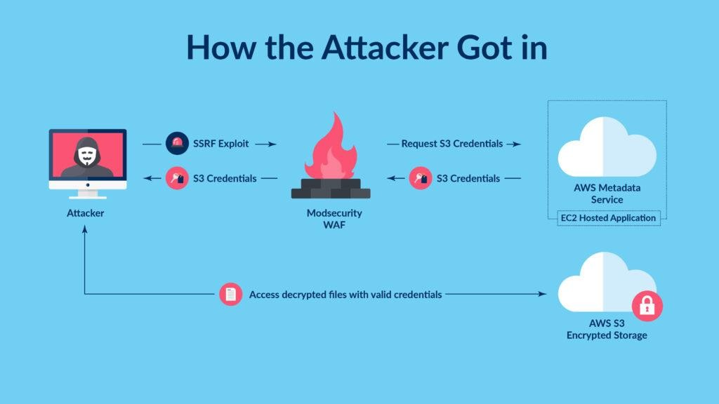

#### Systems Implemented After the Breach:

In response to the breach, Capital One undertook significant steps to strengthen its security posture.The company implemented enhanced security configurations across its cloud-based systems, ensuring that access control policies were tightened and regular audits were conducted to detect potential vulnerabilities.

Encryption protocols were improved to protect sensitive data both at rest and in transit. Capital One also upgraded its threat detection and monitoring systems, leveraging advanced AI and machine learning tools to identify and respond to suspicious activity more rapidly.

Additionally, multi-factor authentication (MFA) and stricter identity and access management practices were enforced across all systems, making it more difficult for unauthorized individuals to gain access to sensitive information in the future.

**Research Area 2**

### JP Morgan Chase (2014 , USA):

The **JPMorgan Chase data breach** in 2014 was a significant cybersecurity incident that affected 76 million households and 7 million small businesses. Hackers accessed sensitive personal information, including names, addresses, phone numbers, and email addresses of JPMorgan customers. However, no account numbers, passwords, Social Security numbers, or credit card details were compromised, limiting the potential for direct financial theft. The breach highlighted vulnerabilities in the bank’s cybersecurity defenses, especially in the face of increasingly sophisticated cyberattacks.

#### How It Happened:

The breach occurred after hackers gained access to JPMorgan’s network through a **compromised server**. The attack exploited a weakness in one of the bank’s servers that had not been properly secured with **two-factor authentication (2FA)**, a common security practice. Once inside the network, the hackers escalated privileges and moved laterally within the system, gaining access to a wealth of customer information. The attack went undetected for several months, during which time the hackers were able to extract sensitive data. It was eventually discovered in July 2014, after JPMorgan’s security team noticed unusual activity within its network.

#### Loopholes That Were Exploited:

The main vulnerability exploited by the hackers was the lack of **two-factor authentication** on one of JPMorgan’s servers, which allowed them to gain initial access to the network. Once inside, the attackers were able to escalate their privileges and move laterally due to **insufficient segmentation** within JPMorgan’s network. The bank’s **monitoring systems** also failed to detect the breach in a timely manner, allowing the hackers to extract data over several months without being noticed. Additionally, while the attackers did not access financial data, the breach revealed weaknesses in JPMorgan’s broader **cybersecurity defenses**.

#### How It Could Have Been Avoided:

Implementation of Two-Factor Authentication (2FA): One of the most critical lessons from the JPMorgan attack is the importance of 2FA for securing all sensitive systems. 2FA would have significantly hindered the hackers' ability to access the internal network, even if they had successfully obtained employee credentials through phishing. Modern financial institutions must ensure that all servers and access points are secured with 2FA or multi-factor authentication to protect against credential theft.

#### Systems Implemented After the Breach:

In response to the breach, JPMorgan significantly upgraded its cybersecurity defenses. The bank invested $250 million annually in improving its **cybersecurity infrastructure**, hiring over 1,000 new security experts, and implementing stronger **encryption protocols**. **Two-factor authentication** was enforced across all systems, and **network segmentation** was enhanced to limit the potential damage of any future breaches. JPMorgan also improved its **threat detection and monitoring capabilities**, leveraging **machine learning** and advanced **anomaly detection tools** to identify suspicious activity in real-time. The bank also partnered with other financial institutions to share intelligence on emerging cyber threats, strengthening the collective security of the banking industry.

## Research Area 3

### WireKard Scandal (2020 , Germany) :

The **Wirecard scandal** in 2020 was a financial fraud case that resulted in the collapse of Wirecard AG, a German payment processing and financial services company. The scandal exposed a massive accounting fraud in which Wirecard falsely claimed that it held €1.9 billion in cash balances that did not exist. This deception unraveled in June 2020, leading to the company’s insolvency, and the arrest of its CEO and other senior executives. The scandal not only shocked the financial world but also raised questions about regulatory oversight and corporate governance.

#### How It Happened:

For years, Wirecard had been inflating its financial statements by reporting non-existent revenue and cash balances in its subsidiaries, particularly in Asia. This was facilitated through **complex accounting practices** and the use of third-party partner companies to generate fictitious revenue. The missing €1.9 billion was supposedly held in trustee accounts in the Philippines, but investigations revealed that these funds never existed. Wirecard’s auditors, **Ernst & Young (EY)**, failed to verify the existence of these funds over several years, allowing the fraud to go undetected. In June 2020, when EY could not confirm the cash balance, Wirecard finally admitted that the funds were likely missing, leading to the company's collapse.

#### Loopholes That Were Exploited:

Wirecard exploited **weak corporate governance** and **inadequate regulatory oversight** to perpetuate the fraud for years. The company’s executives were able to falsify financial records and mislead investors, auditors, and regulators about the company’s true financial health. **Auditor negligence** also played a critical role, as EY failed to verify Wirecard’s cash balances despite red flags and irregularities in its financial statements. The use of **third- party companies** to obscure the real flow of funds further complicated efforts to uncover the fraud.

#### How It Could Have Been Avoided:

The scandal could have been avoided with stronger **auditing standards** and more rigorous **verification procedures**. EY should have performed a thorough audit of Wirecard’s accounts, especially its cash balances, instead of relying on third-party statements. **Tighter regulatory oversight** could have flagged the inconsistencies in Wirecard’s financial reports earlier. Additionally, better **corporate governance** practices, including independent oversight of the company's financial operations, could have helped detect the fraud. **Transparency in financial reporting** and the establishment of **internal controls** would have also mitigated the risk of such a large-scale fraud.

#### Systems Implemented After the Scandal:

In the aftermath of the scandal, regulators and lawmakers in Germany initiated a series of reforms to tighten oversight of the financial sector. The **Federal Financial Supervisory Authority (BaFin)** came under scrutiny for failing to detect the fraud, leading to calls for restructuring and more effective supervision of payment services providers. The role of auditors also faced increased scrutiny, with a push for more **independent auditing** and **rotation of audit firms**. Additionally, Wirecard’s collapse prompted discussions about enhancing **corporate governance** and requiring more **transparent financial reporting** to prevent future fraud.

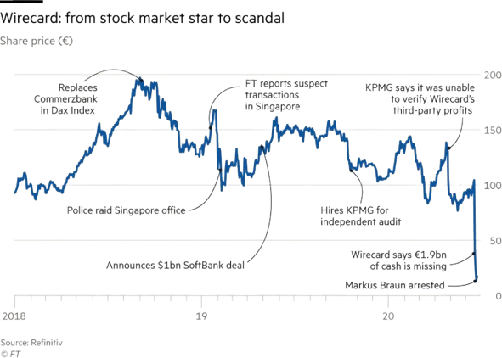

#### Repercussions :

**Consumer Impact**: The personal information of 147 million people, including Social Security numbers, was exposed, leading to potential identity theft and fraud risks. Many individuals had to monitor their credit reports, change personal details, and deal with fraudulent activities.

**Financial Penalties**: Equifax agreed to a settlement of up to $700 million, including compensation for affected consumers, penalties, and credit monitoring services. This became one of the largest settlements related to data breaches.

**Regulatory Scrutiny**: Equifax faced investigations by federal agencies such as the Federal Trade Commission (FTC) and state authorities. It led to stricter data security regulations and discussions about stronger consumer data protection laws.

**Corporate Fallout**: Equifax's reputation took a massive hit. Several executives, including the CEO, resigned following the breach. The company's share price fell significantly as a result of lost trust and the scandal.

**Long-term Effects**: The incident set a precedent for how companies should handle cybersecurity and breach disclosures. It underscored the importance of timely patching and transparency when addressing vulnerabilities

#### Research Area 4:

**The Equifax Data Breach (2017)**

The Equifax data breach, one of the largest and most damaging cyberattacks in history, occurred between May and July 2017, compromising the personal data of approximately 147 million people. The breach exposed highly sensitive information, including names, birth dates, Social Security numbers, driver’s license numbers, and credit card details. Given that Equifax is one of the three largest credit reporting agencies in the U.S., the scale and severity of this breach raised widespread concern about the potential for identity theft and financial fraud.

#### How It Happened:

The breach was caused by a vulnerability in Apache Struts, an open-source web application framework used by Equifax. The vulnerability, CVE-2017-5638, was discovered in March 2017, and a patch was released shortly afterward. However, Equifax failed to apply the security patch in a timely manner, leaving its system exposed. In May 2017, hackers exploited this unpatched vulnerability to gain access to Equifax's systems. Once inside, they were able to move laterally and access sensitive personal information stored in databases. The breach went undetected for over two months, during which time the attackers extracted massive amounts of data before Equifax finally realized the breach in late July 2017.

#### Loopholes That Were Exploited:

The primary loophole was Equifax’s failure to promptly apply the security patch that addressed the Apache Struts vulnerability, despite being aware of the flaw. Additionally, the company’s network segmentation was inadequate, allowing hackers to move freely within the system once access was gained. Furthermore, insufficient encryption of some sensitive data, such as Social Security numbers, made it easier for attackers to retrieve this critical information. The company also lacked effective intrusion detection and monitoring systems, allowing the breach to persist for an extended period without being noticed.

#### How It Could Have Been Avoided:

The breach could have been avoided with better patch management practices. Equifax should have applied the Apache Struts security patch as soon as it was released. Enhanced network segmentation could have limited the attacker’s ability to move within the system and access sensitive data. Encrypting all sensitive information, especially data like Social Security numbers, would have added an extra layer of protection. Additionally, implementing robust monitoring and detection systems would have helped identify unusual network activity earlier, minimizing the scope of the breach. Regular security audits and vulnerability assessments could also have helped prevent such an attack.

#### Systems Implemented After the Breach:

In response to the breach, Equifax overhauled its cybersecurity infrastructure. The company implemented a comprehensive patch management program to ensure all critical vulnerabilities are addressed promptly. They also improved their encryption standards for sensitive data, ensuring that even if a breach occurs, the data is protected. Equifax enhanced network segmentation and added multi-factor authentication (MFA) to strengthen access control. Moreover, they invested in real-time threat detection and intrusion prevention systems, aiming to detect and respond to potential breaches more quickly. The company also committed to conducting regular penetration testing and third-party security audits to continuously assess the security of its systems.

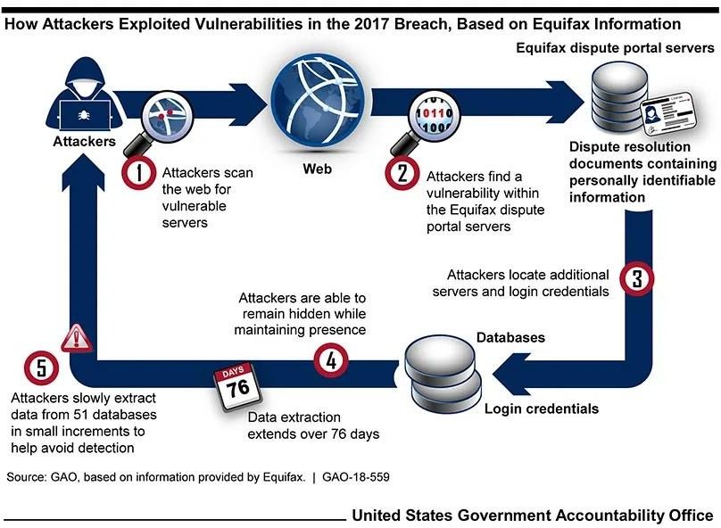

**Repercussions:**

**Financial Collapse**: Wirecard, once valued at over €20 billion, filed for insolvency after admitting that €1.9 billion supposedly held in trustee accounts likely did not exist. This led to massive losses for investors, with the company's stock price crashing by over 90%.

**Legal and Criminal Proceedings**: Multiple Wirecard executives were arrested or charged with fraud, embezzlement, and market manipulation. CEO Markus Braun was detained, and the chief operating officer, Jan Marsalek, became a fugitive.

**Auditor Oversight Failures**: The scandal revealed significant failures in oversight by auditors like EY, who were criticized for not detecting the fraudulent practices earlier. This sparked calls for reform in auditing standards and practices across Europe.

**Regulatory Consequences**: The scandal led to increased scrutiny of financial regulation in Germany. The German financial regulatory authority, BaFin, came under heavy criticism for failing to properly oversee Wirecard's operations and for its weak response to whistleblowers.

**Global Repercussions**: Wirecard's collapse raised concerns about corporate governance and financial fraud in the fintech sector, leading to more stringent regulatory frameworks and a focus on transparency in financial services

# Comparative Analysis

|  |  |  |  |
| --- | --- | --- | --- |
| Incident | Region of Occurence | Reason of the Incident | Lessons learnt from the incident |
| Capital One Data Breach | United States of America , 2017 | A misconfigured firewall in Amazon Web Services (AWS) allowed a hacker to access personal information of over 100 million customers. | Proper configuration and monitoring of cloud infrastructure is critical. Companies should implement strong security protocols and regularly audit systems to identify vulnerabilities. |
| Equifax Data Breach | United States of America , 2019 | A known vulnerability in a web application framework (Apache Struts) was not patched, allowing hackers to steal sensitive personal information of 147 million people. | Timely application of security patches and regular security audits are essential to prevent such breaches. Organizations must adopt proactive cybersecurity strategies |
| WireCard Scandal | Germany , 2020 | Fraudulent accounting practices where Wirecard falsely claimed to hold €1.9 billion in bank accounts that did not exist. | Stronger oversight and transparency are needed in financial reporting and auditing processes to prevent corporate fraud and maintain investor trust |
| JP Morgan Chase Data Breach | United States of America , 2014 | A sophisticated cyber attack compromised the personal information of 83 million accounts due to vulnerabilities in the bank’s security systems. | Even major financial institutions need robust, multi-layered cybersecurity measures and stronger defenses against advanced persistent threats (APTs). Improved coordination with federal regulators and incident response is key |

**Conclusion**

In conclusion, the role of big data in detecting and preventing financial fraud in digital transactions is indispensable. As financial transactions increasingly migrate to digital platforms, the need for robust fraud detection and prevention mechanisms becomes paramount. Leveraging big data analytics offers unparalleled opportunities to enhance fraud detection capabilities, identify emerging threats, and safeguard financial systems against fraudulent activities.

The importance of leveraging big data in detecting and preventing financial fraud cannot be overstated. Big data analytics enables organizations to analyze vast volumes of transactional data, user behavior patterns, and external threat intelligence in real-time, allowing them to detect anomalies, identify suspicious activities, and take immediate action to mitigate fraud risks. By harnessing the power of big data, organizations can improve the accuracy, efficiency, and effectiveness of their fraud detection efforts, protecting their customers and preserving the integrity of financial transactions.

Big data analytics offers significant opportunities for enhancing fraud detection and prevention in digital transactions, enabling organizations to identify patterns indicative of fraudulent activities, detect anomalies in real-time, and respond proactively to mitigate risks. Addressing challenges such as data privacy and security concerns, algorithmic biases, and regulatory compliance is essential to harnessing the full potential of big data in combating financial fraud. Collaboration among financial institutions, regulatory authorities, law enforcement agencies, and technology providers is crucial for sharing information, expertise, and resources, and enhancing collective capabilities in fraud detection and prevention. Policymakers play a critical role in promoting the adoption of big data analytics through the development of data sharing frameworks, regulatory sandboxes, and incentives for collaboration, fostering an environment conducive to innovation and responsible data practices.

As we look to the future, it is imperative that stakeholders continue their efforts to combat financial fraud in digital transactions through the use of big data. This requires ongoing investment in research and innovation, collaboration among stakeholders, and adherence to ethical and regulatory standards. By leveraging the power of big data analytics, organizations can stay ahead of evolving fraud tactics, protect their customers from financial losses, and preserve trust and confidence in digital transactions.

In conclusion, the role of big data in detecting and preventing financial fraud is essential for ensuring the integrity and security of financial systems. By embracing innovation, collaboration, and responsible data practices, stakeholders can build resilient fraud detection and prevention systems that effectively mitigate risks and safeguard the financial well- being of individuals and organizations alike.

**References**

1. Tusneem Elhassan, Hashim Elshafie, Abdu Saif , "Financial Fraud Detection Based on Machine Learning: A Systematic Literature Review" , September 26, 2022 [https://www.researchgate.net/publication/363894144_Financial_Fraud_Detection_Based_on_Machine_Lea](https://www.researchgate.net/publication/363894144_Financial_Fraud_Detection_Based_on_Machine_Learning_A_Systematic_Literature_Review) [rning_A_Systematic_Literature_Review](https://www.researchgate.net/publication/363894144_Financial_Fraud_Detection_Based_on_Machine_Learning_A_Systematic_Literature_Review)
2. Lanxin Jiang, Miklos Vasarhelyi, Chanyuan Zhang , "Towards Real-Time Financial Statement Fraud Detection Using Machine Learning" , January 7, 2022 . <https://papers.ssrn.com/sol3/papers.cfm?abstract_id=4003621>
3. Ezekiel Onyekachukwu Udeh , Prisca Amajuoyi , Kudirat Bukola Adeusi and Anwulika Ogechukwu Scott “The role of big data in detecting and preventing financial fraud in digital transactions” , May 24 ,2024 <https://wjarr.com/sites/default/files/WJARR-2024-1575.pdf>
4. Philip Olaseni Shoetan , Adedoyin Tolulope Oyewole, Chinwe Chinazo Okoye, & Onyeka Chrisanctus Ofodile , “ REVIEWING THE ROLE OF BIG DATA ANALYTICS IN FINANCIAL FRAUD DETECTION”, March 6 , 2024 . [https://www.researchgate.net/publication/379041244_REVIEWING_THE_ROLE_OF_BIG_DATA_ANALYT](https://www.researchgate.net/publication/379041244_REVIEWING_THE_ROLE_OF_BIG_DATA_ANALYTICS_IN_FINANCIAL_FRAUD_DETECTION) [ICS_IN_FINANCIAL_FRAUD_DETECTION](https://www.researchgate.net/publication/379041244_REVIEWING_THE_ROLE_OF_BIG_DATA_ANALYTICS_IN_FINANCIAL_FRAUD_DETECTION)
5. Shahryar Khan , Illya Kabanov , Yunke hua , Stuart Madnick , “A Systematic Analysis of the Capital One Data Breach: Critical Lessons Learned**”** , November 7 , 2022

<https://dl.acm.org/doi/10.1145/3546068>

1. Nelson Neto , Stuart Madncik , “A Case Study of the Capital One Data Breach” , January 13 , 2020

<https://www.researchgate.net/publication/340012934_A_Case_Study_of_the_Capital_One_Data_Breach>

1. Baradhinaran Subburayam , Clement Chiahemba Ajekwe , “Accounting Fraud and Bankruptcy: The Case of Wirecard AG” , September 18 , 2023. [https://www.researchgate.net/publication/373926593_Accounting_Fraud_and_Bankruptcy_The_Case_of_Wire](https://www.researchgate.net/publication/373926593_Accounting_Fraud_and_Bankruptcy_The_Case_of_Wirecard_AG) [card_AG](https://www.researchgate.net/publication/373926593_Accounting_Fraud_and_Bankruptcy_The_Case_of_Wirecard_AG)
2. René Jakubeit , “The Wirecard scandal and the role of BaFin” , May 5, 2021.

<https://leap.luiss.it/wp-content/uploads/2022/09/WP5.21-The-Wirecard-scandal-and-the-role-of-Bafin.pdf>

1. Legal Sidebar , “ JPMorgan Data Breach Involves Information on 76 Million Households, 7 Million Small Businesses” October 23, 2014. <https://sgp.fas.org/crs/misc/breach.pdf>
2. Allen Jeng , Tim Proffitt “Minimizing Damage From J.P. Morgan’s Data Breach” , March 15 , 2015 <https://www.giac.org/paper/gsec/36190/minimizing-damage-jp-morgans-data-breach/143120>
3. Irini Kanaris Miyashiro , “Case Study: Equifax Data Breach” , April 30 , 2021 <https://sevenpillarsinstitute.org/case-study-equifax-data-breach/>
4. Michael Bond , Keiran Human , “ Analysis and Implications for Equifax Data Breach” , October 8, 2018 <https://cs.ucf.edu/~mohaisen/doc/teaching/cap5150/fall2022/cap5150-proj2.pdf>